**Procedure - Install Windows with JDN USB**

This procedure describes how to use the JDN USB to install/re-install your windows 10 on your pc.

1. Power Off your device
2. Plugin the JDN USB
3. Start your device and quickly press several times on F9 to get the boot Menu

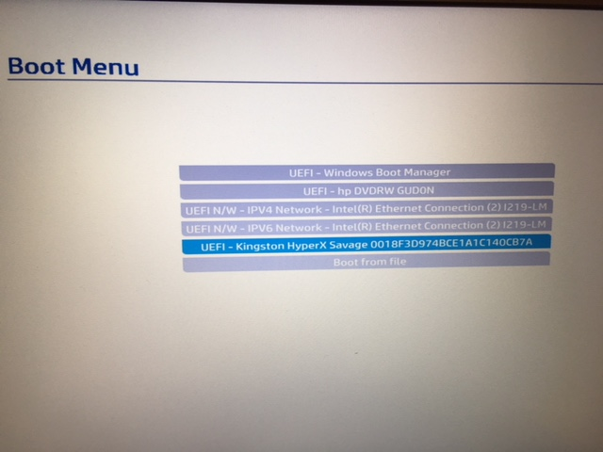

1. Select the one with “...Kingston HyperX...” and click enter

Your device will now the WINPE environment (= this is a pre-windows environment where we will prepare your machine for the windows 10 installation)

You only need to provide wich Keyboard Layout your device has and a computername > check the red label on your device to get the JDN-xxxxx number

Attention the keyboard layout in the WinPe environment is always Querty, so be aware of the computername

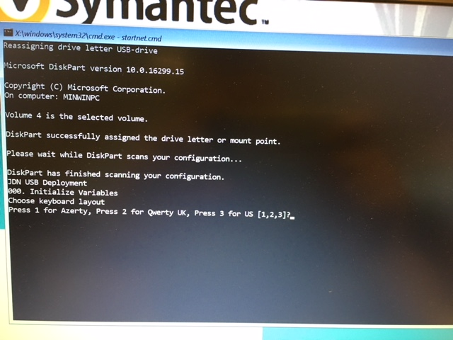

1. Press 1 for Azerty or Press 2 for Querty UK or Press 3 for Querty US

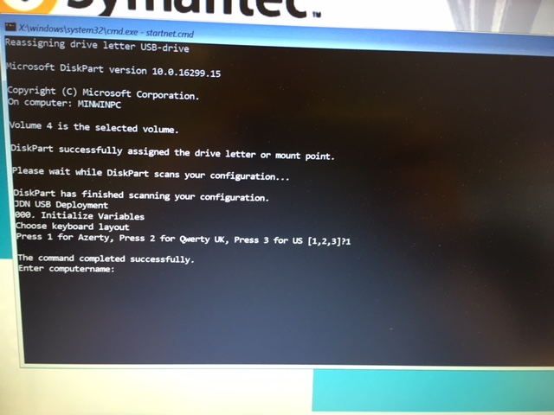

1. Provide the computername > JDN-xxxxx

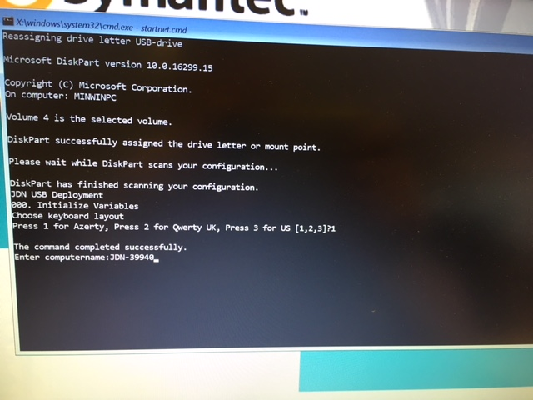

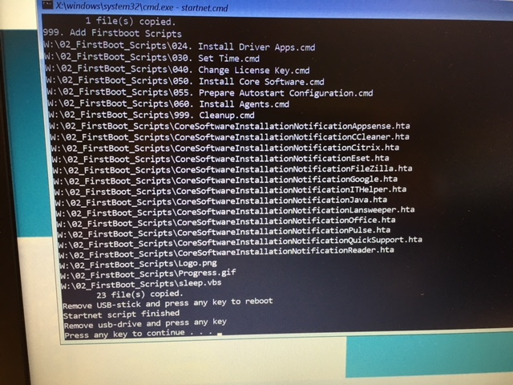

Wait till you get the message ‘Remove usb-drive and press any key” (it takes about 10 minutes for the USB to prepare your machine)

1. Remove the USB from the device and press any key. After that your device will reboot into Windows and starts configuring the Operating System.

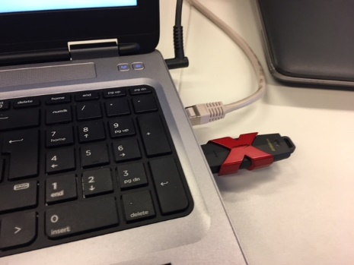 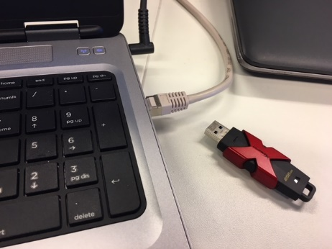

1. Do not touch the device / do not power off the device / do not click on any window when your device is in configuring state

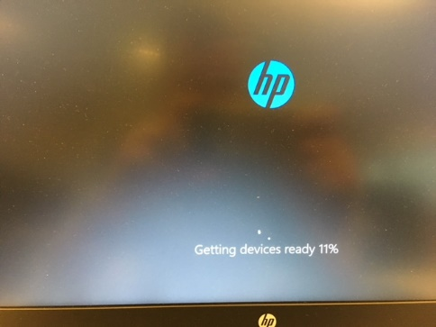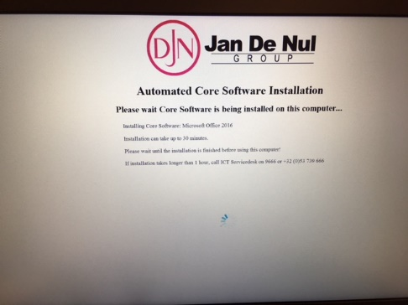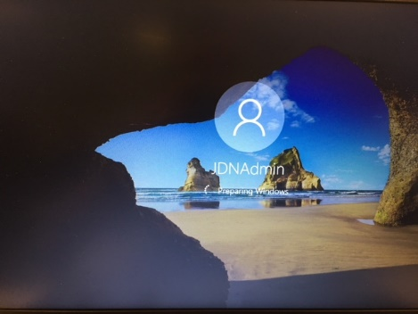

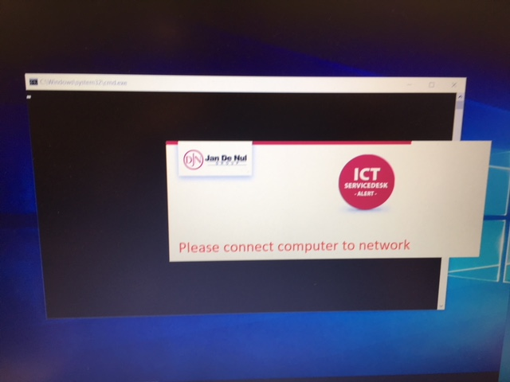

1. When your device receives the above window > make sure your device is connected with a network cable / change the network cable with another one > every 10 seconds the process will check your connectivity again and will disappear when network is found and it will continue its process automatically.

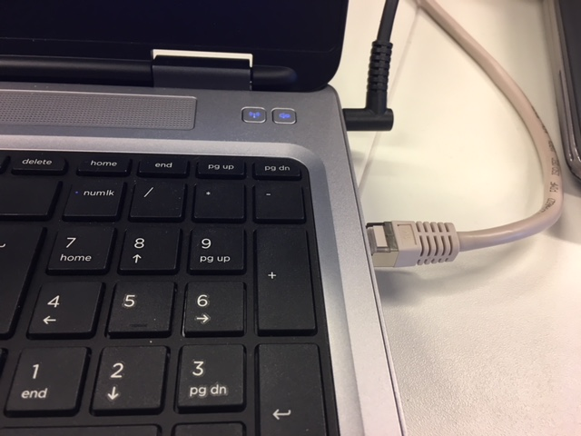

1. Do not touch your device / Do not power off your device when configuring process is being executed

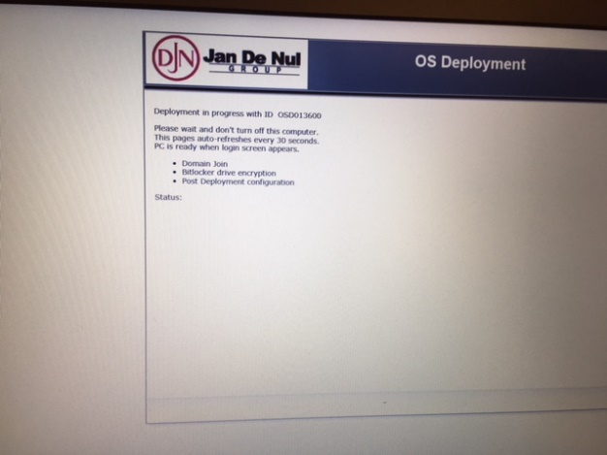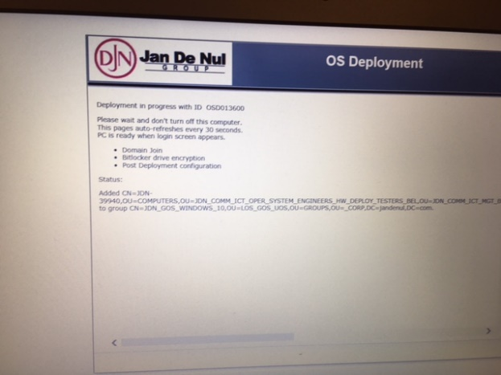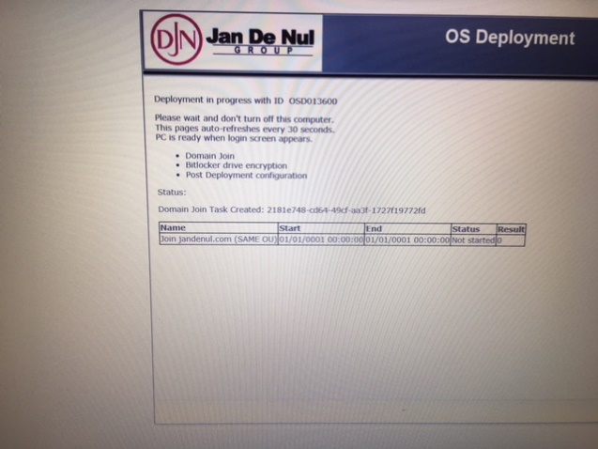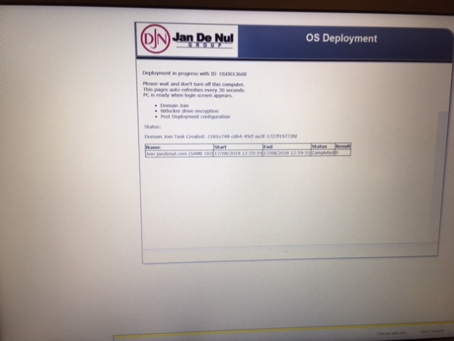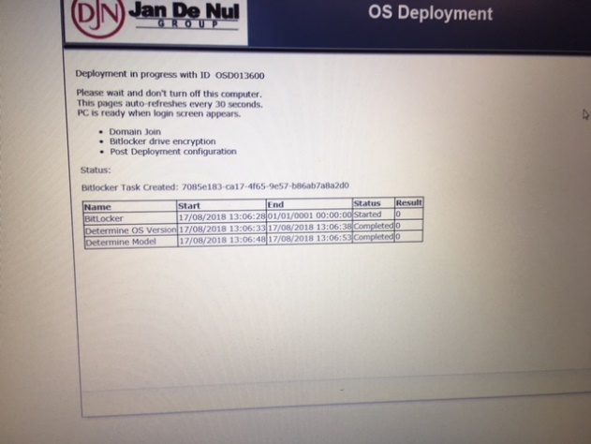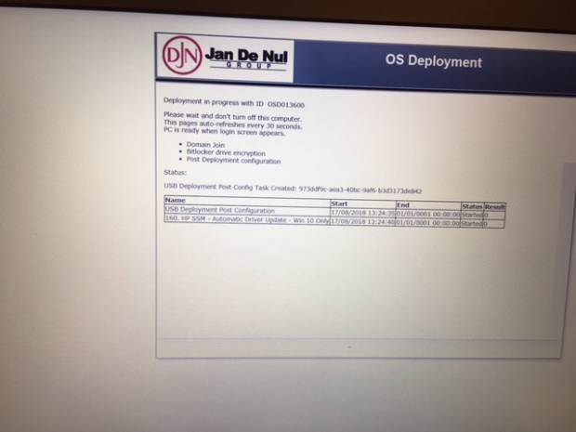

During this process your device will join the jandenul.com domain / bitlock it’s drives / execute some post configuration jobs / disable autologon

1. Your device is ready when your able to provide a password again at the Windows Logon. Here you can change the username ‘JDNAdmin’ and login with your own account.



Workarounds

When after the BIOS upgrade your device doesn’t boot into windows anymore and you get an error the harddisk cannot be found. Check the BIOS if the mode is still in UEFI and not legacy mode

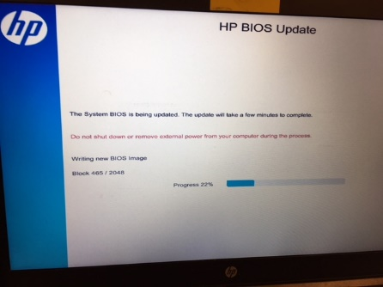 BIOS upgrade process

1. Boot your device and press several times on F10 to get into the BIOS Setup, provide the BIOS password to get the bios information. Go to the tab ‘Advanced’ > ‘Boot Options’

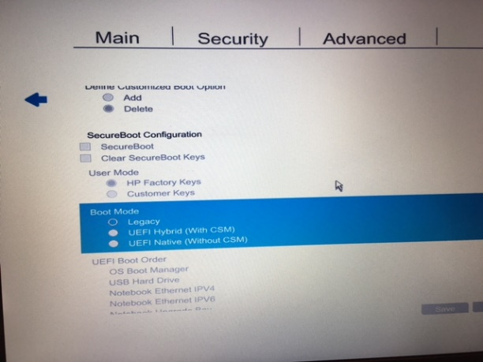

1. Go to ‘Boot Mode’ and if Legacy is selected > click enter and change it into ‘UEFI Native’ mode

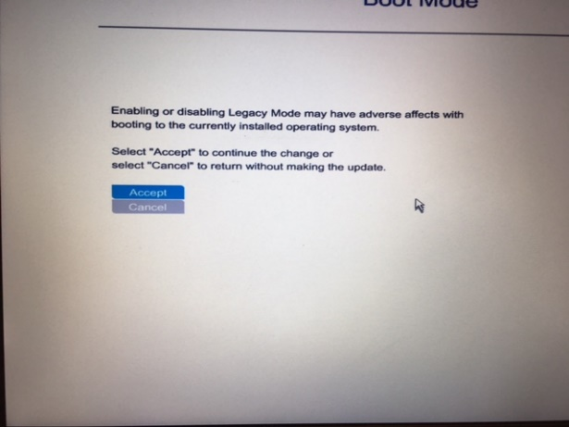

1. Accept the modification

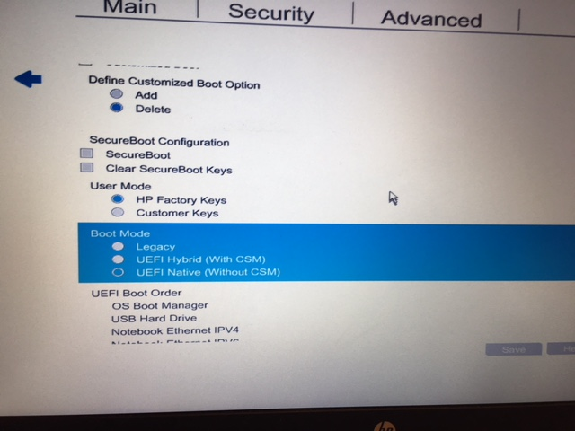

1. Check that UEFI Native mode is now selected

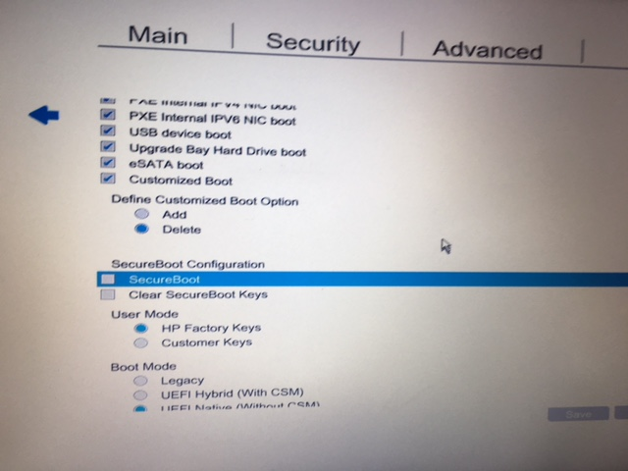

1. Go to ‘Secure Boot’ and select the option by clicking on enter

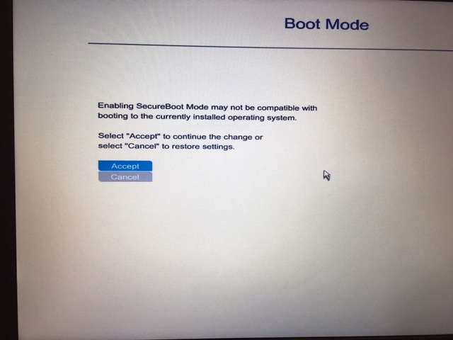

1. Accept the modification

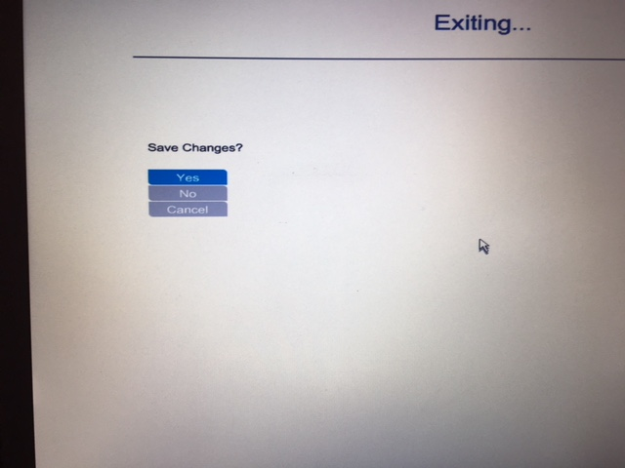

1. Press several times ESC to quit the BIOS > Save your changes by selecting YES

Now your machine will boot again to Windows 10.